**WEEK 2 ASSIGNMENT**

**Weather Dashboard**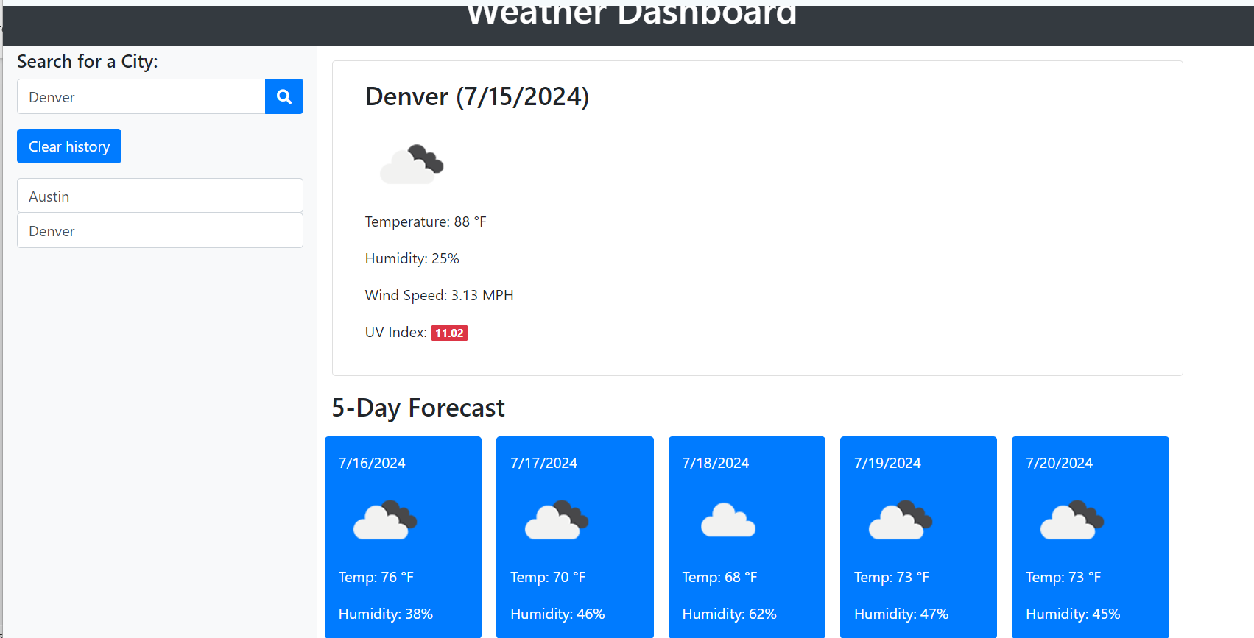

**Strengths:**

Clarity: Presents weather information clearly, with easy-to-read icons and labels.

Design: Uses colours effectively to show different weather conditions.

Usability: Simple interface, allowing users to find their local weather quickly.

Effectiveness: Provides real-time weather updates, forecasts, and alerts.

**Weaknesses:**

Complexity: May lack detailed information for advanced users.

Customization: Limited customization options for specific needs.

**Overall Evaluation:**

This dashboard is highly effective for everyday users needing quick and clear weather information.

**GOOD**

**Fitness Tracker Dashboard**

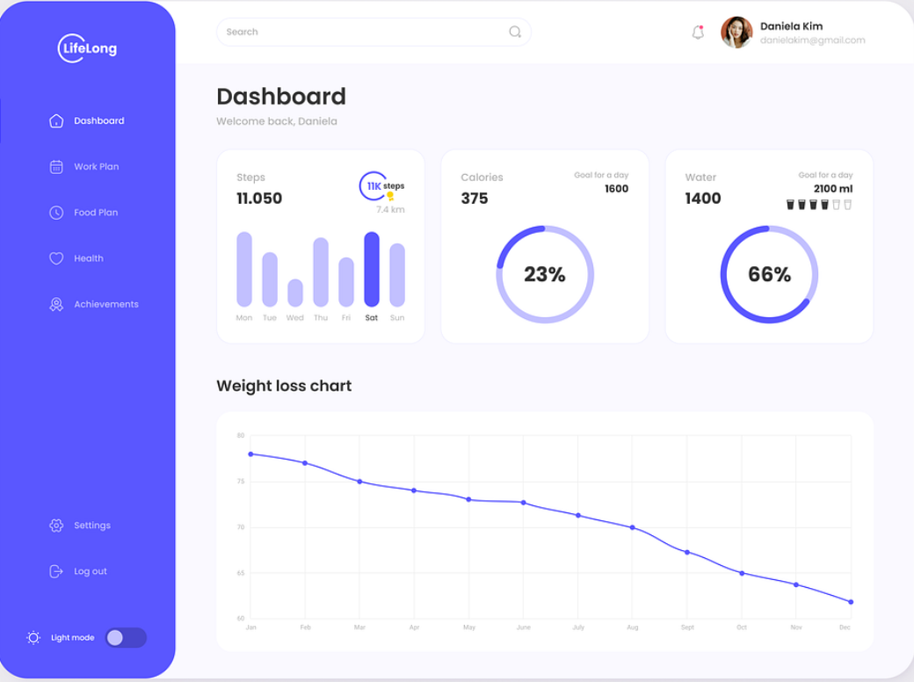

**Strengths:**

Clarity: Displays fitness stats like steps taken, calories burned, and Water consumption in an easy-to-read format.

Design: Attractive layout with charts and progress bars.

Usability: User-friendly interface, making it easy to track daily fitness goals.

Effectiveness: Motivates users by showing progress towards fitness goals.

**Weaknesses:**

Learning Curve: Might require a short learning period for new users.

Customization: Limited ability to add personalized fitness metrics.

**Overall Evaluation:**

This dashboard effectively helps users track and visualize their fitness progress.

**GOOD**

**Budget Tracking Dashboard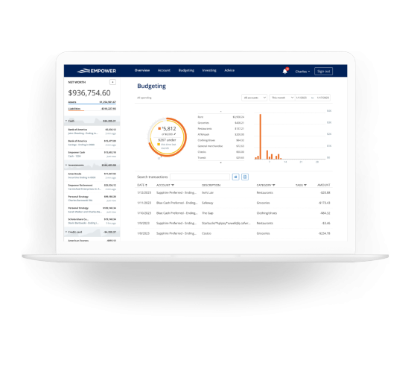Strengths:**

Clarity: Shows income, expenses, and savings clearly.

Design: Clean and organized with pie charts and bar graphs.

Usability: Simple to use, with an intuitive layout for managing finances.

Effectiveness: Helps users keep track of their budget and spending habits.

**Weaknesses:**

Customization: Limited categories for specific budget tracking needs.

Integration: May not integrate with all financial accounts like crypto, stocks etc

**Overall Evaluation:**

This dashboard is highly effective for personal budget management, providing clear insights into financial health.

**Good**

**Incidents Tracking Dashboard**

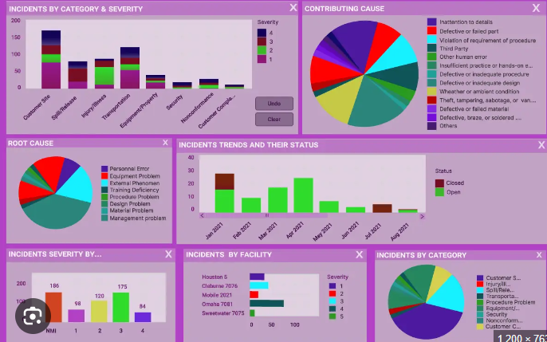

**Strengths:**

Data Rich: Provides comprehensive information on manufacturing incidents, including detailed metrics and trends.

**Weaknesses:**

clarity: The use of multiple, inconsistent colours and an odd background colour detracts from readability and focus.

Design: Overly complex with poor visual design choices that confuse users.

Usability: Difficult to navigate due to distracting colour schemes and lack of a cohesive design.

Effectiveness: Important information is hard to find and interpret due to poor design choices.

**Overall Evaluation:**

Despite having rich data, this dashboard is ineffective due to its poor use of colours and confusing design, making it difficult for users to quickly and accurately interpret the data.

**BAD**

**Business performance Dashboard**

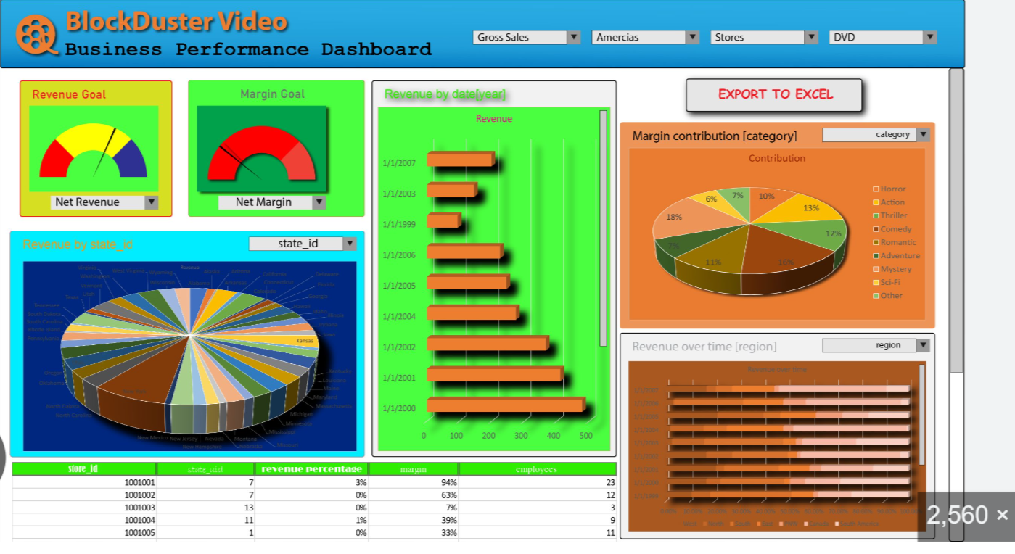

**Strengths:**

Data Rich: Provides comprehensive information on business performance metrics, including detailed financials, sales data, and key performance indicators (KPIs).

**Weaknesses:**

Clarity: The dashboard uses multiple, inconsistent colours, which detracts from readability and focus. Important information gets lost due to colour overload.

Design: The background colour is odd and distracting, causing visual strain. Large details are crammed into a single pie chart, making it difficult to interpret the data accurately.

Usability: The use of improper blur colour effects further confuses the user, making it hard to distinguish between different data points and trends.

Effectiveness: Key insights are obscured due to poor design choices, making it challenging to quickly grasp important business metrics and performance indicators.

**Overall Evaluation:**

Despite having rich data, this dashboard is ineffective due to its poor use of colors, overcrowded pie charts, and confusing blur effects. These design flaws significantly hinder the user’s ability to quickly and accurately interpret the data.

**BAD**

**Monthly Social Media Dashboard**

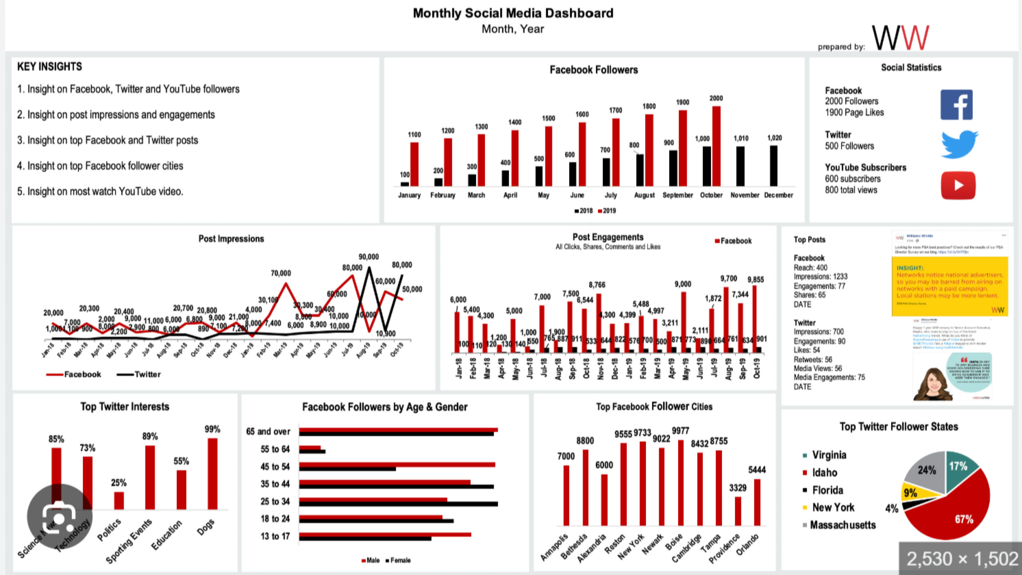 **Strengths:**

Basic Metrics: Includes basic social media engagement metrics.

**Weaknesses:**

Clarity: Insights are located at the top left, which might be overlooked. Multiple bar charts in different directions (right to left, left to right, top to bottom) make it difficult to interpret the data quickly.

Design: Overcrowded with many bar charts, leading to smaller individual chart sizes and mixed-up data. The line graph is a total mess, with values overlapping and difficult to read.

Usability: Hard to navigate and understand due to inconsistent chart orientations and poor layout.

Effectiveness: Fails to effectively communicate key social media insights due to cluttered and confusing design.

**Overall Evaluation:**

This dashboard's poor design and lack of clarity make it difficult to use and understand, thus falling into the category of the worst dashboards.

**BAD**